**Final Project Report**

**Time series prediction**

**Team**

**Ali Ahmad Mansoor 16i-0147**

**Hassan Shabbir 16i-0224**

**Rehan Javed 16i-0140**

**Submitted to**

**Mr. Atif Mughees**

**FAST School of Computing**

**National University of Computer and Emerging Sciences**

**Islamabad, Pakistan**

# Time-Series Prediction

**Objective:**

The project is to predict the future weather of a city using weather-data from several other cities.

**Description of the Problem:**

Weather prediction is one of the most commonly used methodologies. Accurate weather predictions are important for planning our day-to-day activities. Farmers need information to help them plan for the planting and harvesting of their crops.

**Dataset used:**

The raw weather-data was originally obtained from the [National Climatic Data Center (NCDC), USA](https://www7.ncdc.noaa.gov/CDO/cdoselect.cmd).We have used a python module weather provides some functionality to fetch the data from the website.  
  
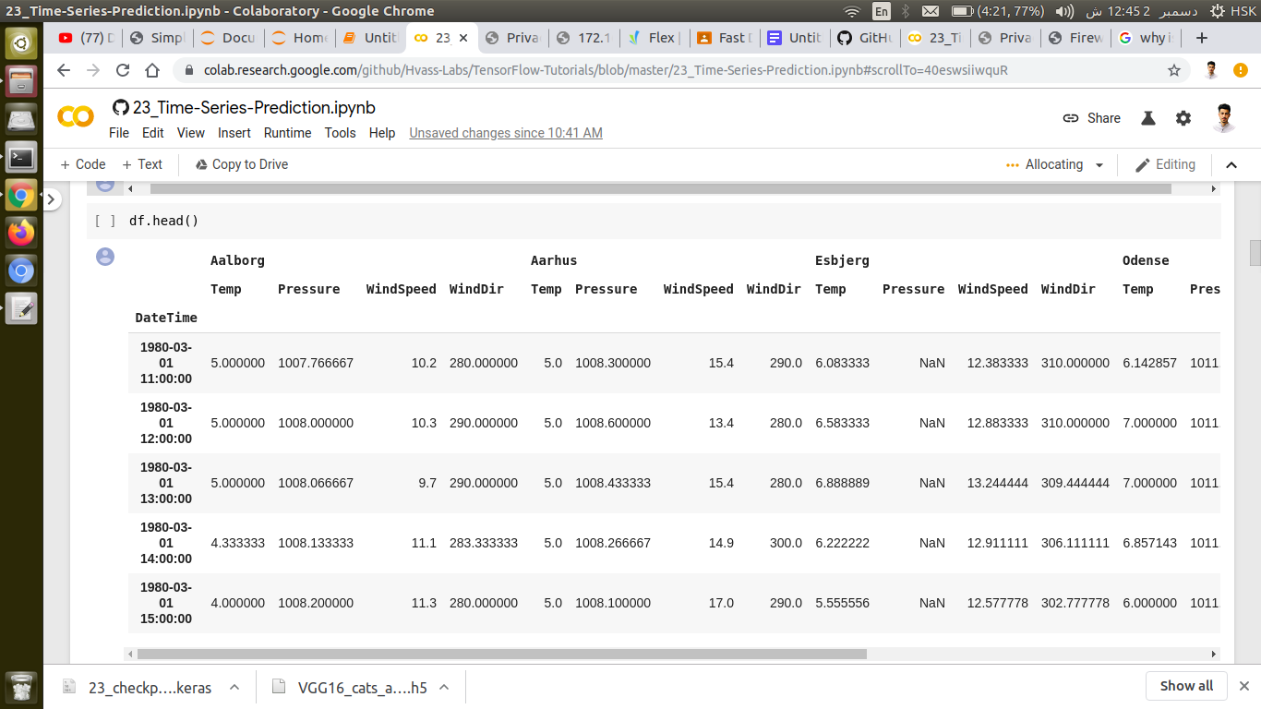

**Proposed Methodology:**

Because we will be working with sequences of arbitrary length, we will use a Recurrent Neural Network (RNN).

In this project, we are trying to predict the weather for the Danish city "Odense" 24 hours into the future, given the current and past weather-data from 5 cities.

We use a Recurrent Neural Network (RNN) because it can work on sequences of arbitrary length. During training we will use sub-sequences of 1344 data-points (8 weeks) from the training-set, with each data-point or observation having 20 input-signals for the temperature, pressure, etc. for each of the 5 cities. We then want to train the neural network so it outputs the 3 signals for tomorrow's temperature, pressure and wind-speed.

**Results:**

Predicted value of temperature vs actual value.

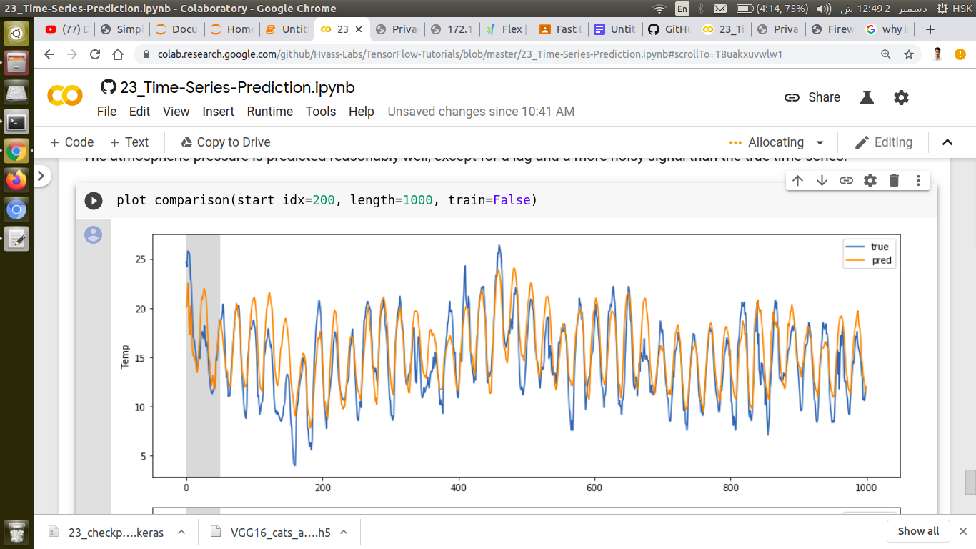

Predicted value of Windspeed vs actual value:

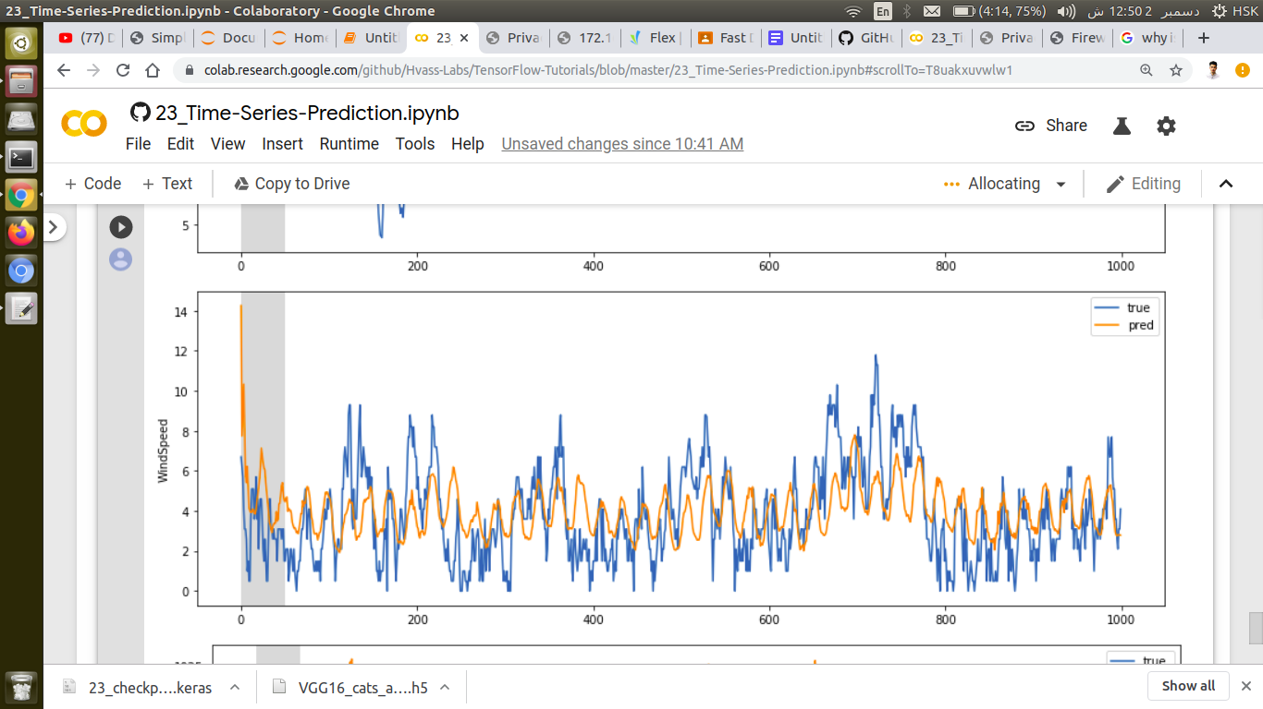

Predicted value of Pressure vs actual value:

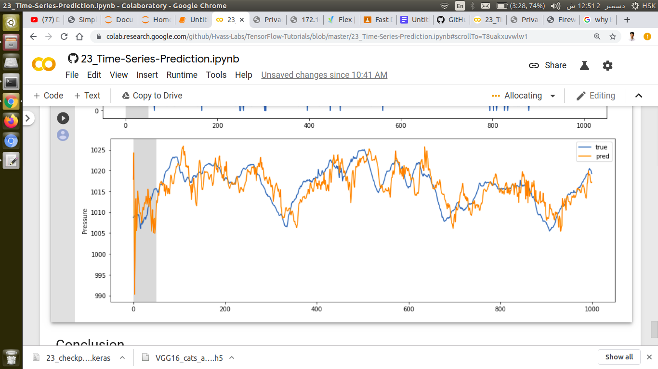

It worked reasonably well for predicting the temperature where the daily oscillations were predicted well, but the peaks were sometimes not predicted so accurately. The atmospheric pressure was also predicted reasonably well, although the predicted signal was more noisy and had a short lag.